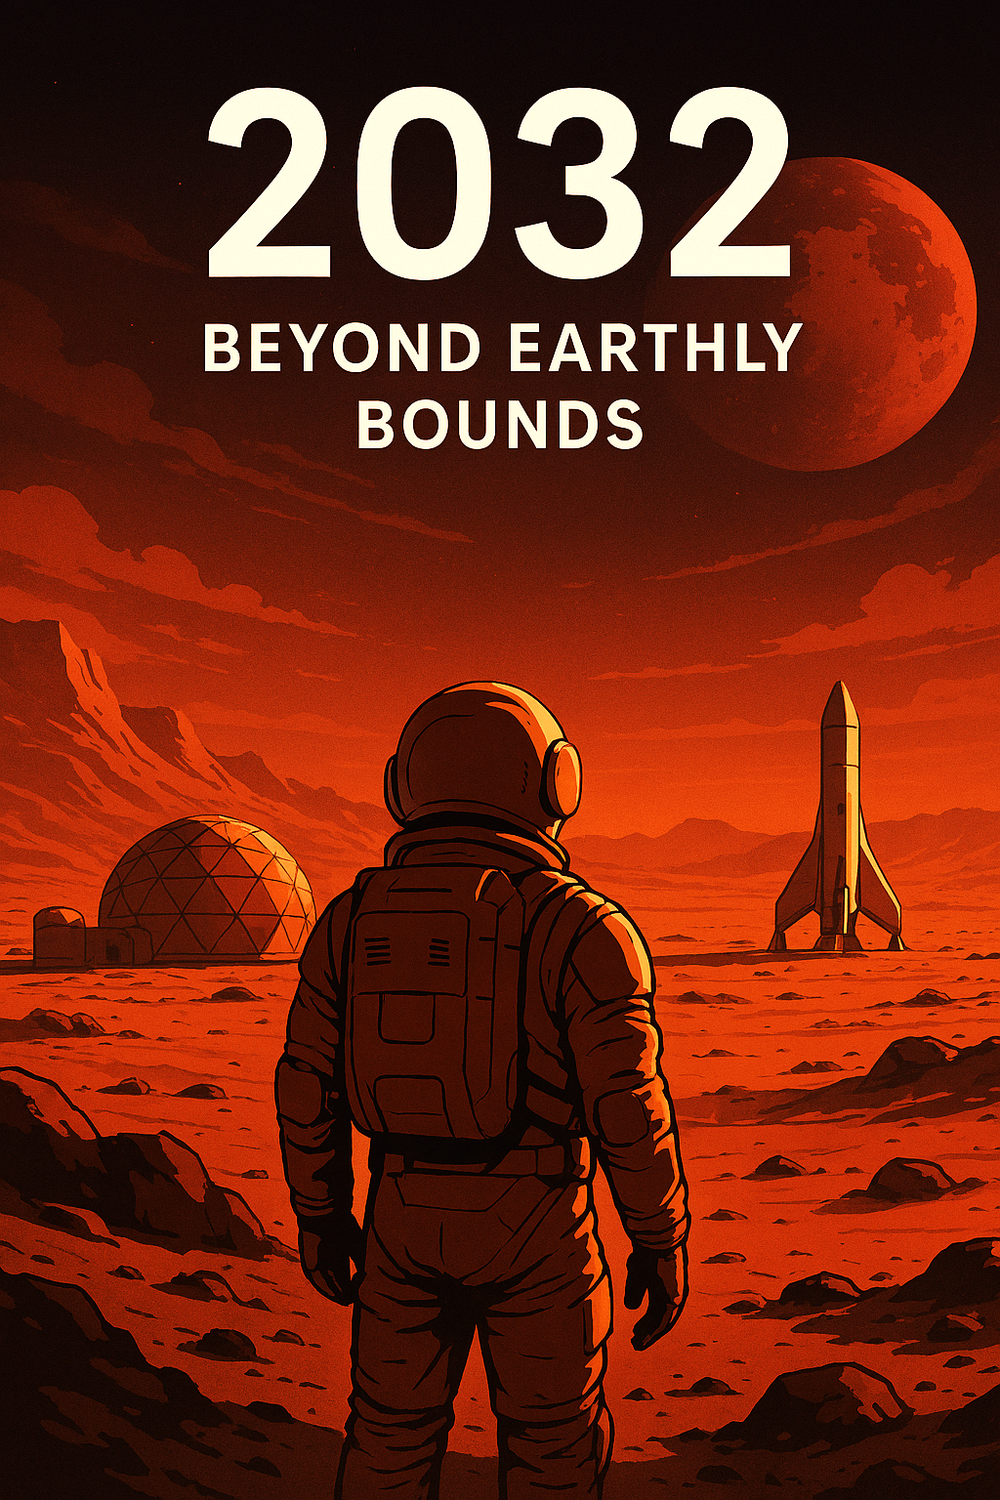
declaration and integritytion of Integrity
We, the undersigned, herewith declare that this cascading group assignment was our own work and that we did not use generative artificial intelligence in our final submission.
We also acknowledge that any violation of the above may lead to disciplinary action by the University of Pretoria being taken in accordance with the policy as set out in the EKN310 Study Guide.

Contribution Table

Student Number | Surname, Initials | Contribution | Signatures
24583172 | Mahlobo, OO | 100% | OOM
21572837 | Nappies, TL | 100% | TN
23908972 | Lidzebe, LW | 100% | LL
23897016 | Mashwama,SS | 100% | S.S MASHWAMA
23540185 | Reddy,PJ | 100% | PR

Word Count (1102)

Beyond Earthly Bounds
What happens when, you cut the cord? Humanity stands at the beginning of its most daring adventure: the colonisation of Mars. No supplies, no lifeline, no second chance. Our mission, Beyond Earthly Bounds. To lead 1000 settlers to an unknown land. It is more than a technological challenge, it is a test of our leadership, resilience, and spirit.

Packing for the Red Planet Adventure: Mars Mission Must-Haves

In order to determine what must be taken to Mars, it is essential to understand the five cornerstones required for a stable society. These include: Power, Food, Healthcare, Education, and provision for Expansion. Governance begins with structured allocation of resources. Of the 75kg permitted per individual, half will be contributed to a communal pool for large-scale infrastructure benefiting everybody.

Approximately 33,5kg of each member's personal stash will be available for clothing, blankets, religious texts and anything chosen by themselves to preserve individual identities and values.

A 500kg nuclear energy system will provide a stable and continuous power source. For food security, each individual must bring 200g of heirloom seeds within their personal allocation. These non-sterile seeds allow replanting after each harvest, guaranteeing continuous food supply.

With electricity available, every member will carry a 800g digital device, functioning solely as an offline library. These devices will store critical knowledge in engineering, agriculture, healthcare, infrastructure, governance, and foundational education.

Healthcare provisions require individuals to bring 3kg of personal and common medications, while 2000kg of communal bioreactors, medical equipment and natural herbs provide supplementary remedies. Finally, 4000kg 3D printers and 3000kg electrolysis units will enable infrastructure development and the conversion of Martian ice into water and oxygen, supporting expansion.

The surplus weight within the communal pool will be allocated for materials that will be used as building blocks for infrastructure, as well as critical back-ups in instances of mechanical failures. Under government control, this inventory includes additional electric motors, metals, and large commercial batteries.
Managing these resources through a democratic government will promote fairness, equal distribution of resources like food and housing, and stability for the new civilisation.

Don't Space Out on Accountability: Governing the Colony
In a Mars colony of 1,000 settlers running on democratic rules, keeping things steady and making sure people are responsible would be key to survival in such a risky place with limited resources. In a democratic governance, decision-making is not in the hands of a single leader or a handful of elites but in the majority. Continuity would be ensured by having a written constitution that clearly defines the roles of institutions, division of powers, fixed terms of office and clear rules of succession. If a leader steps down, is ousted, or cannot effectively perform his or her leadership duties, the constitution has well-established guidelines that ensure a seamless transfer of power, without delays and any confusion regarding the rightful authority.
The use of frequent and short election cycles enables leaders to be replaced without disrupting the administrative continuity, and defining absolute time limits for the use of emergency regulations ensures that swift actions can be taken in an emergency while preventing any individual from abusing the authority for an unlimited period.
Decision-makers would be accountable through multiple levels of democratic processes. The system of elections that are free and fair with all persons having the surety of voting secretly enables the people to gauge the performance of their leaders and to also jettison those performing poorly. If many different viewpoints exist in politics, then that prevents one group from dominating completely.
Transparency has to be a must, with a clear report on the resources allocated and the decisions that led to the policy formulation. Judicial independence would ensure that all the branches of government obey the constitution and recall procedures would enable the people to remove officials before the next election. These safeguards would help maintain equity, stability, and trust among all parties.
Trading Gravity for Growth: The Martian Financial Reset
Creating a new financial infrastructure requires everyone to work together. We will divide the land equally, granting each person a share in the planet's future. At the same time, we will distribute some of the resources we brought, namely, water, minerals and essential supplies, ensuring everyone has a fair chance of survival.
In the initial stage, trade would operate through the barter system, mainly for fruit, vegetable seeds, food production, and essential services. However, as the settlement grand specialisation increases, bartering would become inefficient. The Democratic Republic would then introduce a digital fiat currency, the Mars Credit (MC), issued electronically and used for wages, trade, and taxation. Money would be pumped into the market through public spending and labour compensation.
Why would we do this? The United States moved to a fiat system under Richard Nixon in 1971. This shows us that currency gains its value from not gold but from government authority and taxation (Federal Reserve History, 1971). Just like the Bahamas who introduced a fully digital currency through its central bank (Howcroft & Jones, 2024). These examples validate the need for creating a stable financial dispensation to facilitate trade and fund expansion on Mars.
The infrastructure needed on Mars and how it will be publicly funded
The infrastructure that will be needed on Mars is the In-Situ Resource Utilization System, Modular Power grids, Automated transportation, Agricultural hubs, and Communication and Navigation (called Mars-net). First will be the In-Situ Resource Utilization Systems. These systems extract water from ice, produce oxygen from the atmosphere, and construction materials from the rocks on Mars. Modular power grids will be needed as they produce nuclear power (electricity). Another one is Automated transportation (pressurized rovers), which will provide transport for the citizens, move resources from mines and agricultural hubs. The next one is Integrated life-support and agricultural hubs, which will produce food and agricultural products. Lastly, the communication and navigation infrastructure will be responsible for data sharing, coordination, and precision navigation.
As we build the infrastructure, funding will be needed to build and maintain it. As we will have a democratic government, legislation will be put in place where public funds will be used to fund the building and maintenance of the infrastructure. As the population expands, people will work and get paid, which will lead to taxation being placed and charges made on the usage of water, power, and transportation. The emergence of markets will lead to businesses being levied as well to contribute to the economy, and these funds will be used to maintain the infrastructure.
A Promise to the Stars:Built to Thrive
Colonising Mars shifts the focus from survival to sustainability through democratic resource management and strategic infrastructure. By establishing a stable financial and political system early on. Through these actions, the colony is elevated into something livable and sustainable. The members of the mission do not face the question of how to survive, but rather, how to make their successful mission thrive.

References

de Curtò, J., & de Zarzà, I. (2024). Analysis of Transportation Systems for Colonies on Mars. Sustainability [Accessed 28 February 2026].

Dinkel, H., & Cornelius, J. K. (2024). Vela: A Data-Driven Proposal for Joint Collaboration in Space Exploration [Accessed 28 February 2026].
Donofrio, V., & Kirk, M. (2021). Plan for Building a 1000 Person Martian Colony. arXiv [Accessed 28 February 2026].
Federal reserve history. 2013. Nixon Ends Convertibility of U.S. Dollars to Gold and Announces Wage/Price Controls. Federal reserve history. 22 November. [Online]. Available: Nixon Ends Convertibility of U.S. Dollars to Gold and Announces Wage/Price Controls | Federal Reserve History [Accessed 25 February 2026].
Howcroft, E. & Jones, M. 2024. Bahamas to regulate banks to offer cbank digital currency. Reuter. 1 July. [Online]. Available: Bahamas to regulate banks to offer cbank digital currency | Reuters [Accessed 25 February 2026].
Neukart, F. (2023). Towards Sustainable Horizons: A Comprehensive Blueprint for Mars Colonization. Heliyon [Accessed 28 February 2026].

Polk, C. W. (2014). Reinventing Space Exploration by fostering Direct Demand [Accessed 28 February 2026].

Shishko, R., et al. (2015). An Integrated Economics Model for ISRU in Support of a Mars Colony [Accessed 28 February 2026].

Yazici, A., & Haqq-Misra, J. (2022). Predictions and Possible Solutions for the Sustainability of Mars Settlement. Studia Humana [Accessed 28 February 2026].

Civics Academy. (n.d.). What are the key features of a democracy? Civics Academy. [Accessed 26 February 2026].
United Nations. (n.d.). Democracy | United Nations – Global Issues. United Nations. [Accessed 26 February 2026].
Office of the United Nations High Commissioner for Human Rights. (n.d.). About democracy and human rights. OHCHR. [Accessed 26 February 2026].

